# Kosrae Invasive Species Taskforce

# Strategic Action Plan 2013 – 2015

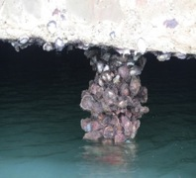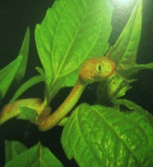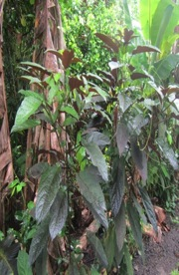

## Description: C:\Users\Robert H. Jackson\Documents\KISTPix\COT.JPG

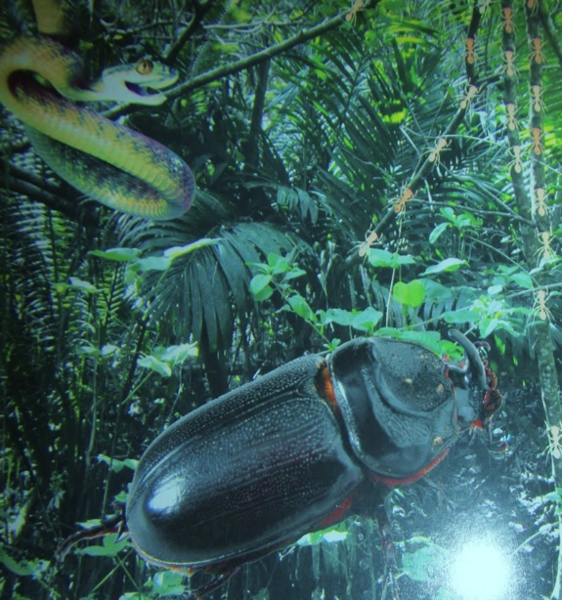

## Description: C:\Users\Robert H. Jackson\Documents\KISTPix\KIRMA ACTIVITIES 001.jpg

## Description: C:\Users\Robert H. Jackson\Documents\KISTPix\CiarPa 024.JPG

## Tofol, Kosrae, May 2013

## Table of contents

Acronyms 3

Acknowledgement 3

1.0 Executive summary 5

2.0 Introduction of Invasive Species 6

3.0 Background 6

3.1 Workshop objectives 6

3.2 Expected outcomes 7

3.3 State planning framework 7

3.4 KIST Members 8

4.0 Vision 8

5.0 Mission 8

6.0 Challenges 8

7.0 Strategic goals and objectives 9

Table 7.1Funding 10

Table 7.2Public awareness 11

Table 7.3 Commitment 12

Table 7.4 Capacity building (training and technical assistance) 13

Table 7.5 Coordination 14

Table 7.6 Policy and legislation 15

8.0 Species work plans 16

8.1 Targeted species: 2013 - 2015 work plans 17

Table 8.1 Terrestrial Species: *Chromoleana odorata* (Mah nani), *Clerodendrum* *quadriloculare* (Sra sroninmutuk), and *Lucaena* spp*.* (Tangantangan) 19

Table 8.2 Marine Species: Pacific oyster *(Crassostrea gigas*) andCrown-of-thornstarfish *(Acanthaster planci)* 19

Annex 1. KIST SWOT Analysis 20

Annex 2. Kosrae Invasive Species Taskforce Charter 21

Annex 3. Priority and “early detection” Invasive Species 23

Table 1: Priority Species 23

Table 2: Species to be monitored for early detection 24

Annex 4. Map of Invasive Species – Presence and Programs 25

### Acronyms

CBO Community Based Organizations

CDO Community Development Office

COM College of Micronesia

DREA Department of Resources and Economic Affairs

DTI Department of Transportation and Infrastructure

FSM Federated States of Micronesia

IAS Invasive Alien Species

KBSAP Kosrae Biodiversity Strategy and Action Plan

KCSO Kosrae Conservation and Safety Organization

KIRMA Kosrae Island Resource Management Authority

KIST Kosrae Invasive Species Taskforce

KSG Kosrae State Government

MIC Micronesians Leaders in Conservation

NBSAP National Biodiversity Strategy and Action Plan

NGO Non-governmental Organization

NRCS Natural Resource Conservation Service

PILN Pacific Invasives Learning Network

PIST Pohnpei Invasive Species Team

RISC Regional Invasive Species Council

SAP Strategic Action Plan

SBDC Small Business Development Center

SPC Secretariat of the Pacific Community

SPREP Secretariat of the Pacific Regional Environment Programme

SWOT Strengths, Weaknesses, Opportunities and Threats

TNC The Nature Conservancy

UNDA United States Department of Agriculture

USFS United States Forest Service

### Acknowledgement

KIST wishes to thank Ponphei Invasive Species Team for sharing their multi-agency action plans, and Lucille Apis-Overhof and Mae Adams from the Nature Conservancy and Jill Key from the Pacific Invasives Learning Network for their assistance in facilitating a workshop the inaugural KIST workshop in Kosrae.

*Photographs: Crown-of-thorns and Pacific Oyster licensed under Creative Commons; other photographs provided by KIRMA staff.*

### 

### 1.0 Executive summary

The Kosrae Invasive Species Taskforce (KIST) has identified 6 thematic areas of concern for invasive species management in Kosrae State: Funding, Public Awareness, Commitment, Capacity Building, Coordination, and Policy and Legislation. Longer-term strategic goals and objectives have been established for each thematic area.

KIST has identified three species of terrestrial plant for immediate priority action under this Strategic Action Plan (SAP): *Chromolaena ordorata* (Siam weed; mah nani), *Clerodendrum quadriloculare* (Bronze leaf; sra sroninmutuk), and *Leuceana* spp. tree (Tangantangan). Two marine invasive species, Crown-of-thorns starfish(*Acanthaster planci*) and Pacific oyster *(Crassostrea gigas*) will also be targeted for control.

The SAP establishes goals, objectives, activities, collaborators, timeframes, sources of funding, and estimated costs for control of these species. Work plans have been developed to address these terrestrial plants and marine species, linked to the KIST mission, and implemented through to the end of 2015.

### Description: E:\KIST\IMG_0151.JPG

### 2.0 Introduction of Invasive Species

Invasive alien species have caused major biodiversity losses, impose ecosystem disturbance and severely affect the economy and human livelihood on islands worldwide. Islands are very vulnerable to biological invasions. Invasive species are known to have directly or indirectly caused or contributed to the decline and extinction of many marine species, birds, reptiles, mammals and plants. For example, exotic invasive ants disrupt traditional outdoor lifestyles and cause harm to people and their crops; invasive weeds compete with other plants for space, nutrients and some overgrow and kill useful plants; the introduction of marine invasive species disrupt other marine species; and snakes like the brown tree snake in Guam cause significant economic losses due to power outages and biodiversity losses, such as the extinction of several native bird species. In addition, feral pigs cause serious damage to people’s gardens, resulting in crop loss.

Islands present unique opportunities to manage invasive species. Three main ways of managing invasive species are prevention, eradication, or control. Preventing invasions by freshwater, marine and terrestrial species should be more achievable on islands than on continental locations. Eradication should be considered if an invasive species is newly introduced and not wide spread.

Many invasive species found in neighboring countries and States are not present in the Kosrae. Therefore a high priority must be given to preventing the introduction of such invasive species.

### 3.0 Background

In November 2006 the Pohnpei Invasive Species Team (PIST) produced simple, realistic multi-agency action plans for priority invasive species that were seen as a model by other invasive species groups in the region. A multi-agency workshop was held in Kosrae in May 2007, the outcomes of which were the formation of the Kosrae Invasive Species Taskforce and the first KIST Strategic Action Plan 2006-2009. The SAP was revised at a KIST workshop held in 2012.

#### 3.1 Workshop objectives

Workshop objectives were as follows:

* Develop a vision – where we want to be in 3 years time;
* Develop strategic goals for invasive species management;
* Develop the long-term (3 years) objectives;
* Integrate invasive species objectives with other plans (Kosrae Land Use Plan, KBSAP, etc);
* Prioritize the main thematic areas;
* Draft simple and realistic multi-agency action plans for the priority objectives;
* Define the national coordination mechanism and how it will function.

#### 3.2 Expected outcomes

At the end of the workshop agencies and individuals in Kosrae State working on invasive species will continue to have a clear long-term vision of where they want to be in 3 years time, and will have developed the short-term roadmap (in the form of simple, realistic action plans) of how to get there. In addition, the internal coordination mechanism will have been identified.

#### 3.3 State planning framework

The KIST invasive species action plan forms a focal plan under the KBSAP, within the State planning framework as indicated in the following diagram.

**Kosrae State ACTION Plan**

Agriculture Development Plan

Kosrae Biodiversity Strategy and Action Plan

Kosrae Land Use Plan

Kosrae Invasive Species Taskforce

The Kosrae Invasive Species Taskforce (KIST) is the coordination mechanism for all the State plans with regard to invasive species issues. A KIST Charter has been drafted as an activity under Theme 5 Coordination: Goal 1, and is provided in Annex 2.

#### 3.4 KIST Members

The members of KIST are:

* COM Land Grant Program
* Department of Education
* Department of Health
* Department of Resources and Economic Affairs
* Department of Transport and Infrastructure
* Kosrae Island Resource Management Authority
* Kosrae Conservation and Safety Organization
* Kosrae Farmers Association
* Kosrae Small Business Development Centre
* Kosrae Women’s Association
* Municipal Governments Lelu, Malem, Tafunsak and Utwe
* Quarantine
* Yela Environmental Landowners Association

### 4.0 Vision

Kosrae will have sustainable freshwater, marine and terrestrial ecosystems, with priority invasive species under active management and high public awareness of their impact, to ensure the environmental, cultural, social and economic well being of present and future generations.

### 5.0 Mission

KIST will ensure that all preventative measures are undertaken so that the introduction of new species is minimized, and via collaboration across all levels of society (government, NGOs, churches and community) and cooperation with neighboring countries, will work to prevent, and minimize the impact of existing and/or new invasive species.

### 6.0 Challenges

An assessment of the strengths and weaknesses and opportunities and threats (SWOT Analysis[[1]](#footnote-1)) (Annex 1) of invasive species management in Kosrae identified of challenges in six thematic areas:

1. Funding
2. Public awareness
3. Commitment
4. Capacity building
5. Coordination
6. Policy and legislation

### 7.0 Strategic goals and objectives

KIST has developed a set of realistic and achievable goals that best address the challenges under each thematic area. These are set out in tables 7.1 to 7.6 below.

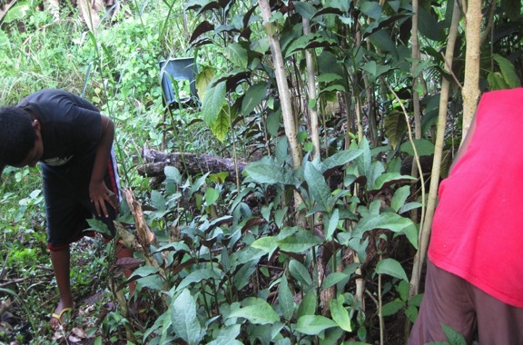

|  |  |  |  |  |
| --- | --- | --- | --- | --- |
| Table 7.1Funding | | | | |
| **Goals** | **Objectives** | **Activities** | **Resources** | **Output** |
| 1. By 2015 KIST will **have raised over $150,000 from** local, regional and international donors**, to support and finance its operation**. | * 1. By 2013 all committed donors will be identified   2. By the end of 2013 draft proposals will be in place   3. Secure funding by beginning of 2014.   4. **By 2013, at least one member of the KIST will be trained as a grant writer.** | * Obtain necessary information on donors and project needs * Identify donors for the different project needs * Arrange and meet with donors on a one on one basis * Develop, review, and submit concept documents/proposals to the donors * Identify or hire a grant writer | State gov’t, Nat’l gov’t, local gov’t, NGOs, local, regional and international NGOs, USFS, USDA, SPREP, SPC. | Funded projects |

|  |  |  |  |  |
| --- | --- | --- | --- | --- |
| Table 7.2Public awareness | | | | |
| **Goals** | **Objectives** | **Activities** | **Resources** | **Output** |
| 1. By 2015 at **least 50% of the community** will be fully aware of the **negative** impact / effects of invasive species.  **2. By 2015, all farmers in Kosrae will be fully aware of the impacts and effects of invasive species and are equipped to control the spread of invasive species.** | * 1. By 2015**, all identified target groups will be involved in awareness programs.**   2. By the end of 2015, **the KIST's** education plan **will be fully** implemented.   3. Promote awareness on **invasive species control and management.**   4. **By 2014, invasive species will be integrated to the School Curriculum.** | * **Conduct quarterly meetings with stakeholders.** * **Monitor and assess implementation of activities in the education plan.** * **Develop awareness materials for schools, communities and target group.** * **Work with the Department of Education on the school curriculum.** * **Hold community awareness on legislation in all 5 communities.** | KCSO, KIRMA / Local, State and National Gov't  **DREA, DOE,**  **Stakeholders** | Public are proactive in invasive species management |

|  |  |  |  |  |
| --- | --- | --- | --- | --- |
| Table 7.3 Commitment | | | | |
| **Goals** | **Objectives** | **Activities** | **Resources** | **Output** |
| 1. To get endorsement of **revised KIST SAP by the Governor and Legislature**  **2. Maintain commitment of government funding** | * 1. **By 2012, revise KIST SAP in accordance with the Regional, National, State, and Local SAP**   2. **By mid 2013, review of KIST SAP by all stakeholders.**   3. **By end of 2013 endorsement of KIST SAP by Governor and Legislature.** | * Revise and update KIST SAP * Review of KIST SAP by members * Formally present KIST SAP to government, local government and NGO's * Endorsement of KIST SAP by government | KIST, State government, Municipal Government, NGO's | Evidence of commitment by having endorsed KIST SAP |

|  |  |  |  |  |
| --- | --- | --- | --- | --- |
| Table 7.4 Capacity building (training and technical assistance) | | | | |
| **Goals** | **Objectives** | **Activities** | **Resources** | **Output** |
| 1. Continue to build capacity for effective invasive species management in Kosrae | * 1. By end 2013, identify areas that require technical assistance   2. By end 2013, identify who would benefit from capacity building   3. **By end 2014, identify additional training opportunities available to both Marine & Terrestrial Invasive Management**   4. Ensure the training realized is shared internally as much as possible, by KIST members being trained as trainers.   5. **Promote and strengthen trainings to local partners.** | * **To identify types of training available** * **Train appropriate officers** * Trained officers share their new skills / knowledge with local partners * **Establish & maintain communications with donors and regional organizations** | KIST, SPC, SPREP, TNC, PILN, MIC, KCSO**, RISC**, Embassies, regional and international organizations. | A list of training opportunities available  KIST members trained as trainers  **New Partnership established and Donors identified** |

|  |  |  |  |  |
| --- | --- | --- | --- | --- |
| Table 7.5 Coordination | | | | |
| **Goals** | **Objectives** | **Activities** | **Resources** | **Output** |
| 1**. Continue** strengthening the role of KIST | * 1. Increase the support and participation from government departments, agencies, NGOs and other members.   2. KIST becomes the State coordination mechanism for invasive species issues | * Carry out workshops and training to strengthen collaboration * Hold meetings quarterly * Share information on projects, challenges and plans * Clarify priorities and roles for each member of the KIST | DREA, YELA, KIRMA, SPC, State & Municipal (CBO) government, KCSO, church groups, women’s groups, AG office | KIST is fully capable of carrying out their roles / responsibilities and supported by various sectors |
| 2. Coordination of activities by key stakeholders in the State, affected by invasive species issues | 2.1 Stakeholders fully performed and implementing their responsibilities.  **2.2 Participate in State, National and regional invasive species initiatives including RISC** | * Continue to conduct meetings / Public Awareness * Involve stakeholders in all Invasive activities | KIRMA, DREA, KCSO, SPC, State & Municipal governments (CBO) churches, women’s association | Stakeholders fully aware of and know their roles and responsibilities |

|  |  |  |  |  |
| --- | --- | --- | --- | --- |
| Table 7.6 Policy and legislation | | | | |
| **Goals** | **Objectives** | **Activities** | **Resources** | **Output** |
| 1. Implement and Enforce state laws and municipal ordinances for effective management of invasive species | * 1. KIST to share invasive species issues with the Kosrae State and municipal law-making body.   2. Identify the legal needs for effective invasive species management.   3. Endorse legislation to enforce the containment of invasive species by 2013.   4. Improve coordination of law enforcement bodies.   5. Define a clear policy direction for invasive species management in Kosrae state. | * Identify stakeholders for sharing information and awareness within the state government and municipalities * Continue awareness programs throughout the island * Public hearings to explain laws * Endorse legislations and ordinances required for effective invasive species management | KIRMA, KCSO, YELA, NRCS, CFSM, KSG, SPC, COM-FSM/Land Grant, DREA, Women’s Organization, Churches, municipal government, AG's office, Legislature R&D Committee, Community Groups (Senior Citizens) | State law and / or ordinances in place  Public awareness of new legislation |

### 8.0 Species work plans

The following work plans are based on the KIST mission, where it states that the introduction of new invasive species will be minimized, and existing invasive species eradicated or controlled. The work plans focus on selected invasive species for control or eradication activities.

The three plant species were selected on the basis of current, on-going activities, and invasive species impacts of priority concern.

1. *Chromolaena ordorata*, local name mah nani.
2. *Clerodendrum quadriloculare*, local name sra sroninmutuk.
3. *Luceana* sp. tree, local name Tangantangan.

KIRMA and partner agencies have conducted a survey, monitoring and collection of Crown-of-thorns starfish and Pacific oysters around the island.

#### Description: group3-small8.1 Targeted species: 2013 - 2015 work plans

*Chromolaena ordorata*; Siam weed, local name “mah nani”.

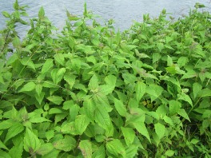

*Cleodendrum quadriloculare*; Bronze leaf, local name “sra sroninmutuk”.

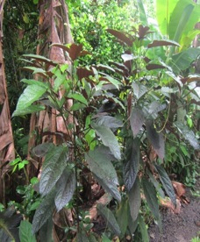

*Luceana* spp.tree; local name “Tangantangan”.

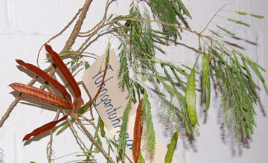

*Acanthaster planci*; Crown-of-thorns starfish

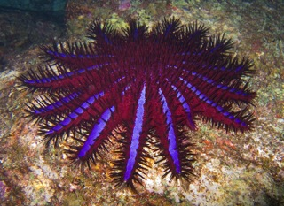

*Crassostrea gigas*; Pacific oyster

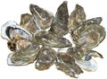

##### Table 8.1 Terrestrial Species: *Chromoleana odorata* (Mah nani), *Clerodendrum* *quadriloculare* (Sra sroninmutuk), and *Lucaena* spp*.* (Tangantangan)

|  |  |  |  |  |  |  |  |  |  |  |  |  |  |  |
| --- | --- | --- | --- | --- | --- | --- | --- | --- | --- | --- | --- | --- | --- | --- |
|  | | | 2013 | | | | 2014 | | | |  | | | |
| **Goal** | **Objective** | **Activities** | **Qtr 1** | **Qtr 2** | **Qtr 3** | **Qtr 4** | **Qtr 1** | **Qtr 2** | **Qtr 3** | **Qtr 4** | **Outputs** | **Partners / resources** | **Funding** | **Funding Sources** |
| Conserve biodiversity and livelihoods | By the end of each year, another 0.25 acre of infested sites should be controlled | i. Continue bi-monthly visits and treatment | X | X | X | X | X | X | X | X | 1. All 3 species   ii. At least 0.25 acre of invested sites should be controlled | Forestry  KIST | $15,000 | Compact II |

##### Table 8.2 Marine Species: Pacific oyster *(Crassostrea gigas*) andCrown-of-thornstarfish *(Acanthaster planci)*

|  |  |  |  |  |  |  |  |  |  |  |  |  |  |  |
| --- | --- | --- | --- | --- | --- | --- | --- | --- | --- | --- | --- | --- | --- | --- |
|  | | | 2013 | | | | 2014 | | | |  | | | |
| **Goal** | **Objective** | **Activities** | **Qtr 1** | **Qtr 2** | **Qtr 3** | **Qtr 4** | **Qtr 1** | **Qtr 2** | **Qtr 3** | **Qtr 4** | **Outputs** | **Partners / resources** | **Funding** | **Funding Sources** |
| Conserve biodiversity and livelihoods | Educate public on impacts of marine spp. and how to control them | 1. Public awareness and control methods. 2. People’s consumption (food etc). 3. Continue monitoring and control spp | X | X | X | X | X | X | X | X | 1. Collaborate with partners to control and manage spp. 2. Research for any food preparations, using the meat | KIST  Fishermen  Land Grant  FAO | $7,000 | Existing funds and Compact II, Land Grant, MCT, SGO, PII |

### Annex 1. KIST SWOT Analysis

|  |  |
| --- | --- |
| **Strengths** | **Weaknesses** |
| * Good representation of various agencies, departments, NGOs * Invasive species task force established * Accessible to local media sources * Government and community support * Existing on-going preventative methods * One small island * Available resources (human, some financial) * Not too late - still have time (to prevent, eradicate) * Small population, makes public awareness easier * Good on-going programs already * Access to external resource people (SPC, SPREP, PILN etc) | * Limited financial support - funding cut-off * Insufficient public awareness * Inactive taskforce (to be very honest with you) * No SAP in place * No government endorsement * Limited access to individual properties * Overlapping / duplication of responsibilities of different agencies * Lack of technical support and facilities * Not a priority for the government of Kosrae * Import of herbicides and safe usage, training (certified applicators) * Lack of policy and legislation |
| **Opportunities** | **Threats** |
| * KIST established (government, NGOs, CBO) * Public education (awareness) and support * KIST (collaborators) to continue and improve public awareness * Geographic location * Utilize existing learning networks / information exchange (PILN, etc) * Funding assistance available (SEP, embassies etc.) * Technical assistance from abroad * Capacity building, including learning exchanges | * Limited funding * Community obligations * Less and lack of commitment from leaders / government * Lack of knowledge and support from community * Less resources (personnel, experiences, equipment, etc) * Small input to biosafety system * “Who cares?” attitude * Politicians commitment and decisions |

### Annex 2. Kosrae Invasive Species Taskforce Charter

**1. Establishment**

The Kosrae Invasive Species Taskforce (KIST) was established at the invasive species action planning workshop held in Tofol, Kosrae, 25 – 26 April 2007.

**2. Vision**

Kosrae will have sustainable freshwater, marine and terrestrial ecosystems, with priority invasive species under active management and high public awareness of their impact, to ensure the environmental, cultural, social and economic well being of present and future generations.

**3. Mission**

KIST will ensure that all preventative measures are undertaken so that introduction of new species is minimized, and via collaboration across all levels of society (government, NGOs, churches and community) and cooperation with neighboring countries, will work to prevent, control and minimize the impact of existing and/or newly introduced invasive species.

**4. Members**

The following agencies are members of KIST:

* COM Land Grant Program
* Department of Education
* Department of Health
* Department of Resources And Economic Affairs.
* Department of Transport and Infrastructure
* Kosrae Island Resource Management Agency
* Kosrae Conservation and Safety Organization
* Kosrae Small Business Development Center
* Kosrae Women’s Association
* Municipal Governments of Lelu, Malem, Tafunsak and Utwe
* Quarantine
* YELA Environmental Landowners Association

**5. KIST Coordinator**

The coordinator is an individual, not an agency, nominated and agreed by a majority of KIST members, who assumes the office for a period of 1 year. Coordinators can be re-elected if supported by a majority of members. A majority of KIST members can agree to replace an existing coordinator at any time.

The KIST coordinator has the following responsibilities:

* Convene and chair the meetings
* Produce the meeting agenda
* Prepare the minutes of each meeting, and distribute it to members
* Delegate tasks to other KIST members in accordance with the work plan
* Nominate a member responsible for monitoring progress of the work plans
* Actively encouraging full attendance and participation of KIST members in meetings and tasks

**6. Meetings.**

Meetings will be held on a quarterly basis, convened by the coordinator with at least 3 working days notice. The coordinator produces an agenda for each meeting. A quorum of 10 KIST members who represent at least 3 agencies must be present for a meeting to proceed.

**7. Member commitments.**

In the interests of preventing the introduction of new invasive species and reducing the impact of existing ones, KIST members agree to:

* Attend meetings and avoid delegating as much as possible
* Participate fully in the meetings
* Collaborate with other agencies in invasive species activities
* Coordinate their activities as much as possible with other agencies
* Respect each other’s individual agency mandates
* Respect each other as professionals
* Inform KIST of their agencies activities, achievements and challenges
* Accept reasonable delegation of actions from the coordinator and comply within the agreed time

**8. Decisions**

Decisions will be made on the basis of the following criteria:

* Will it advance the KIST mission?
* Is it in the KIST SAP?
* Is it realistic?
* Is it fair and acceptable to all KIST members?

### Annex 3. Priority and “early detection” Invasive Species

##### Table 1: Priority Species

|  |  |  |
| --- | --- | --- |
| *Scientific Name* | *Common Name* | *Kosraean* |
| **Plants** | | |
| *Leuceana spp.* | Leuceana | Tangantangan |
| *Clerodendrum quadriloculare* | Bronze leaf | Sra sroninmutuk |
| *Chromolaena odorata* | Sian weed | Sra nani |
| *Clerodendrum paniculatum* | Pagoda flower |  |
| *Clerodendrum chinense* | Honolulu rose | Rose Honolulu |
| *Mimosa invisa* | Giant sensitive plant | Sra mutul |
| *Syngonium podophyllum* | Arrowhead vine |  |
| *Bauhinia variegata* | Orchid tree |  |
| *Wedelia trilobata* | Singapore daisy |  |
| *Hippobroma longiflora* | Star of Bethlehem |  |
| *Lantan camara* | Lantana |  |
| *Eichornia crasspies* | Water hyacinth |  |
| **Invertebrates / Vertebrates** | | |
| *Achatina achatina* | Giant African snail |  |
| *Aleyrodidae* family | White fly |  |
| *Paracoccus marginatus* | Papaya mealybug |  |
| *Xanthomonas citri subsp. citri* | Citrus canker |  |
| *Neotermes rainbowi* | Kalotermitid Dampwood |  |
| **Marine species** | | |
| *Acanthaster planci* | Crown-of-thorns starfish |  |
| *Crassostrea gigas* | Pacific oyster |  |
| *Siluriformes* | Catfish |  |

##### Table 2: Species to be monitored for early detection

|  |  |  |
| --- | --- | --- |
| *Scientific Name* | *Common Name* | *Kosraean* |
| **Plants** | | |
| *Albizia lebbeck* | Siris-tree |  |
| *Clidemia hirta* | Koster’s curse |  |
| *Coccinia grandis* | Ivy or scarlet gourd |  |
| *Imperata cylindrica* | Cogon grass |  |
| *Miconia calvescens* | Purple plague |  |
| *Spathodea campanulata* | African tulip tree |  |
| **Invertebrates / Vertebrates** | | |
| *Boiga irregularis* | Brown tree snake |  |
| *Oryctes rhinoceros* | Coconut rhinoceros beetle |  |
| *Wasmannia auropunctata* | Little fire ant |  |
| **Marine species** | | |
| *Oreochromis niloticus* | Nile tilapia |  |

### 

Annex 4. Map of Invasive Species – Presence and Programs

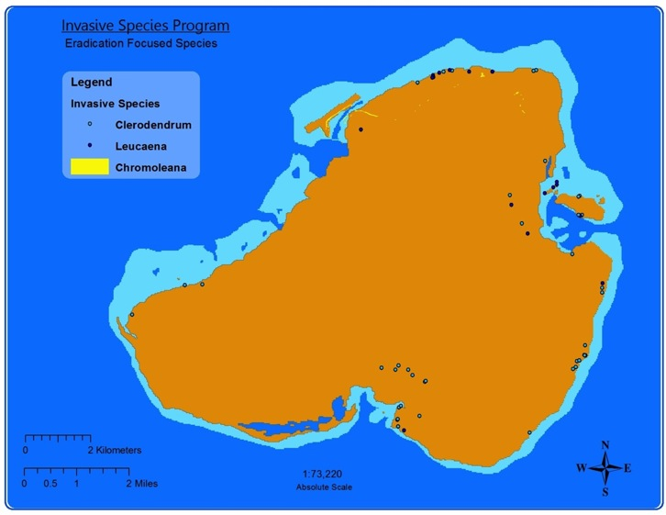

1. SWOT Analysis - Analysis of external strength, weaknesses and identification of opportunities and threats that a team, taskforce, or agency is currently facing. [↑](#footnote-ref-1)