Situation Report (SITREP)

SITREP No. 001 Name/contacts of person completing this report: C. R. Felix

Date/time of SITREP: 04 – 15 – 2026/1444hrs Date/time of incident: 04 – 11 – 2026/0300hrs – 0400hrs

Location of incident: Latitude: 7º26’47.93” N Longitude: 151º50’22.77” E

Description of location (e.g. name, distance and bearing to nearest landmark): Chuuk State Seaport – Weno, Chuuk

Nature and source of incident (indicate which of the following, identify vessels/specific source where possible):

- Vessel aground/collision and leaking oil: _ _ _ _ _ _ _ _ _ _ _ _ _ _ _ _ _ _ _ _ _ _ _ _ _ _ _ _ _ _ _ _

- Vessel underway and discharging/leaking oil: _ _ _ _ _ _ _ _ _ _ _ _ _ _ _ _ _ _ _ _ _ _ _ _ _ _ _ _ _

- Vessel at anchor/moored/berthed and discharging/leaking oil: _ _ _ _ _ _ _ _ _ _ _ _ _ _ _ _ _ _ _ _ _

- Land-based source: _ _ _ _ _ _ _ _ _ _ _ _ _ _ _ _ _ _ _ _ _ _ _ _ _ _ _ _ _ _ _ _ _ _ _ _ _ _ _ _ _ _ _

- Oil slick with no definite source: _ _ _ _ _ _ _ _ _ _ _ _ _ _ _ _ _ _ _ _ _ _ _ _ _ _ _ _ _ _ _ _ _ _ _ _ _

- Other (please describe): 2 vessels aground – “Chief Mailo” & “Ballina”; “Chief Mailo” capsized – starboard side, oil sheen emanating from said vessel.

Visual appearance and extent of pollution (estimate area and quantity if possible): Oil sheen visible, emanating from capsized vessel (“Chief Mailo”), no emulsification yet; area coverage – 0.12 mi², estimate of 50 – 80 US gallons of marine diesel fuel.

Direction and rate of drift of pollution: North – northeast, drift rate @ 0.3 – 0.38 knots
Wind speed & direction: 14kt – 15kt Southwind, Northward Sea state: WMO 4 (Moderate). Significant wave height 3’ – 5’. Small to moderate waves with occasional whitecaps. Residual swell from Typhoon SINLAKU diminishing. Tide: Low tide

Events since POLREP/last SITREP: _ _ _ _ _ _ _ _ _ _ _ _ _ _ _ _ _ _ _ _ _ _ _ _ _ _ _ _ _ _ _ _ _ _ _ _ _ _ _ _ _ _ _ _ _ _ _ _ _ _ _ _ _ _ _ _ _ _ _ _ _ _ _ _ _ _ _ _ _ _ _ _ _ _ _ _ _ _ _ _ _ _ _ _ _ _ _ _ _ _ _ _ _

(Attach additional information if required)

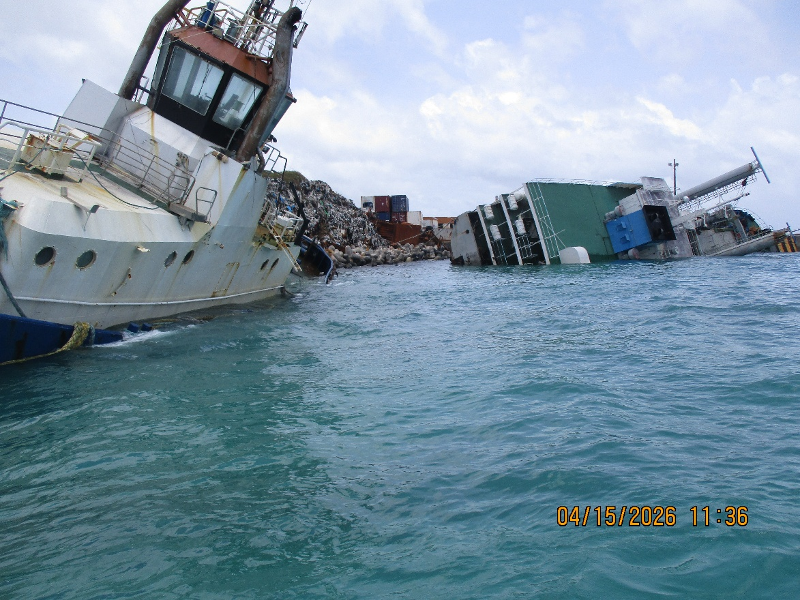

Vessels Ballina & Chief Mailo grounded on the northern face of Chuuk State Seaport on Weno, Chuuk. Ballina (left side) grounded, but no visible oil leakage; Chief Mailo (right side) grounded & capsized on starboard side, oil sheen emanating from vessel.
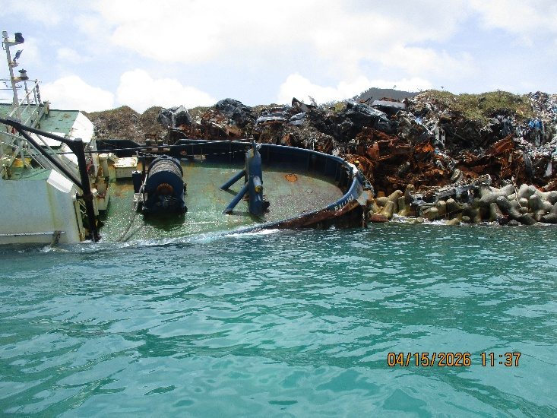
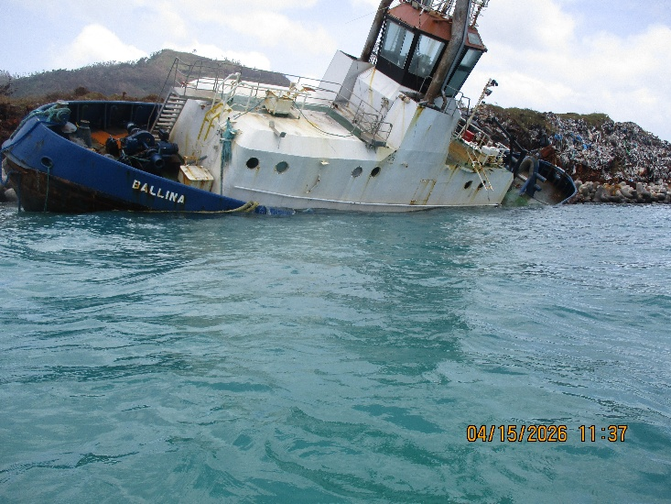

Shown in both pictures, starboard side of Ballina, no visible oil sheen or oil slick on water surface.

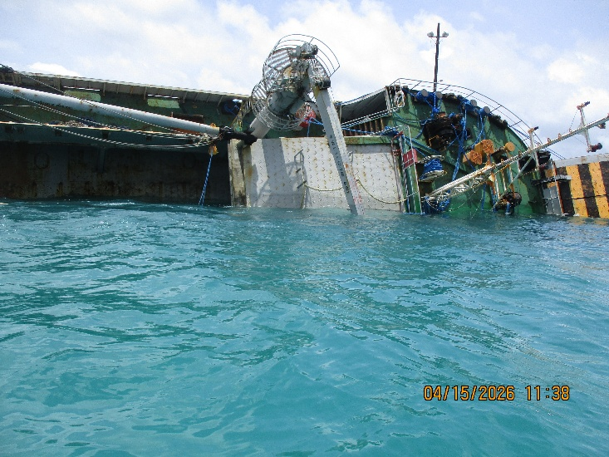
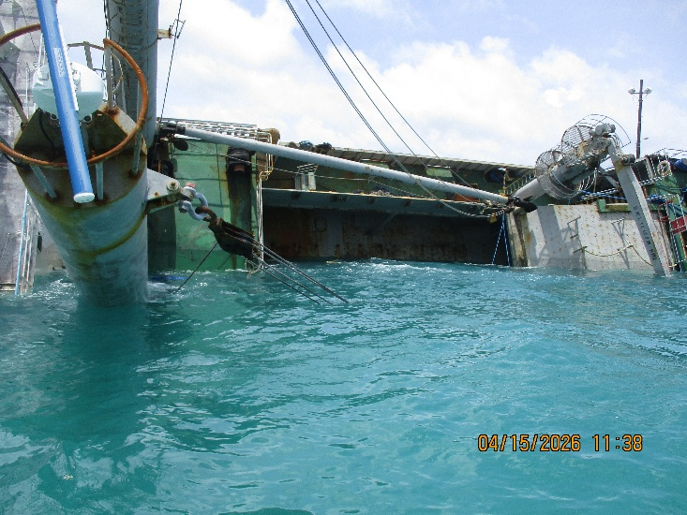
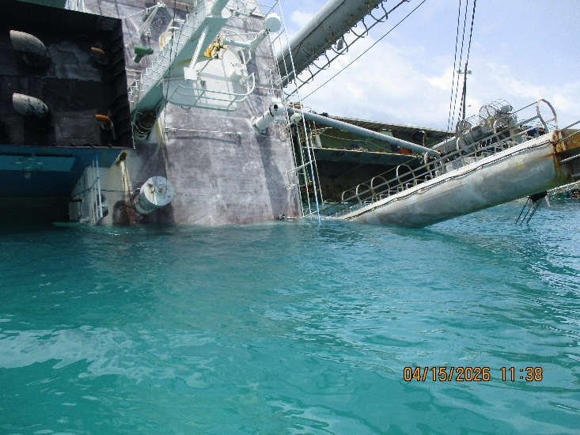
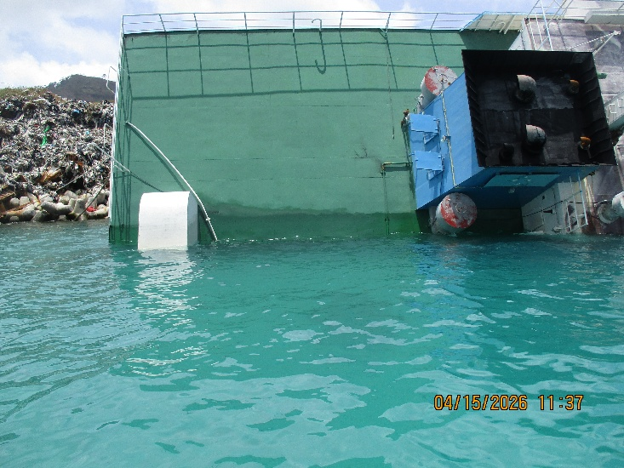

All four pictures show the deck of Chief Mailo.

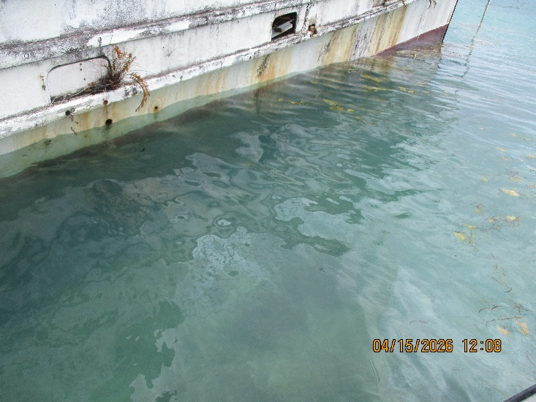
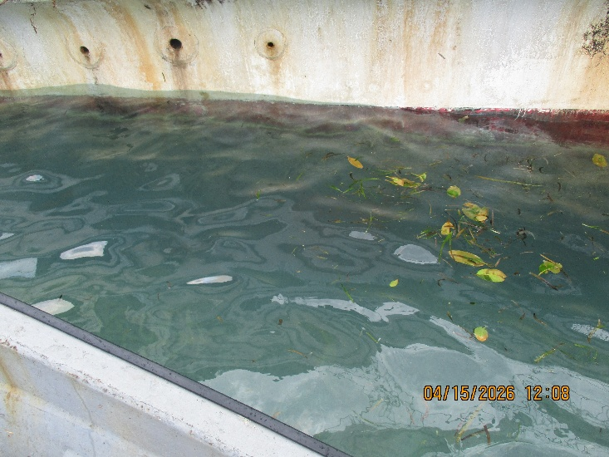

Vessel shown is a 45 – foot fiberglass fishing boat grounded on the southeastern end of Fonoton. No visible oil slick, with minimal oil sheen due to fuel/lubricant residue within the vessel.

