**Pohnpei and Kosrae States**

**Federated States of Micronesia**

**Early Action Rainfall Watch**

The Early Action Rainfall Watch provides sector managers with a brief summary of recent rainfall patterns, particularly drought and the rainfall outlook for the coming months.

**Issued: 12/11/2023**

**Current El Niño-Southern Oscillation (ENSO) status:** The NOAA ENSO Alert System Status as of November 09: El Niño is anticipated to continue through the Northern Hemisphere spring (with a 62% chance during April-June 2024).

NOAA ENSO Alert System Status: El Niño Advisory

**Status summary to November 2023:**

In **November 2023** (1-month timescale) Very wet condtions were observed at Pohnpei, Mokil, Pingelap, Nukuoro, Ngatik, Kapingamarangi and Kosrae. No extreme conditions for Oroluk.

Over **September to November 2023** (3-month timescale) Very Wet conditions were observed at Pohnpei, Mokil, Pingelap, Ngatik, Nukuoro, Kapingamarangi and Kosrae. No extreme conditions for Oroluk.

Over **June 2023 to November 2023** (6-month timescale) Very Wet conditions were observed at Pohnpei, Kosrae and all of the outer islands.

**Outlook summary:**

For **December 2023**, there is a Very high chance of very dry conditions north of Oroluk. For Pohnpei, Mokil, Pingelap, Ngatik and Kosrae there is a High chance of very dry conditions. For Nukuoro, there is a medium chance of very dry conditions. For Kapingamarangi, there is a low chance of extreme rainfall. Past accuracy for December chance of extreme rainfall outlooks has been moderate to high for these locations.

For **January 2024**, there is a high chance of Very Dry conditions for Pohnpei, Kosrae and all outer islands except Kapingamarangi which has low chance of extreme rainfall. Past accuracy for November chance of extreme rainfall outlooks has been low to high for these locations.

For **February 2024**, there is a Very high chance of Very Dry conditions over Oroluk. For Pohnpei, Mokil, Pingelap, Ngatik and Nukuoro there is a high chance of Very Dry conditions. For Kosrae, there is a medium chance of Very Dry conditions and low chance of extreme rainfall for Kapingamarangi. Past accuracy for December chance of extreme rainfall outlooks has been moderate to high for these locations.

**Impacts**

After the specified period the agricultural and hydrological systems listed below are likely to be impacted. Note the periods are estimates only. Allow for uncertainty associated with island size, geology and soil type. Contact your local Disaster Coordination Office for more information on impacts.

**For Pohnpei State**

**Very Dry impacts**

**1-month is most relevant for**: Shallow rooted crops (e.g., cucumbers, bell pepper, eggplant, cabbage), pink eye outbreak (outer islands), water hour (scheduled)

**3-months is most relevant for**: Sakau, Low water level in Dam, socio-economic stress, increasing cost of food crops, outer islands schools close, firing (wild fires), bush/forest fires, outer islands wells dry up, cholera and skin disease outbreak, purchase of water tanks for outer islands (1000 gallons), boiling of drinking water

**6-months is most relevant for**: Yam, banana, tapioca, sweet potato, wells dry up, theft and burglary, main island river and streams running low, main island schools close

**12-months or more**: Giant Taro, citrus trees, breadfruit, coconut, mango, betelnut, outer island migration

**Very Wet impacts**

**1-month is most relevant for**: rotting of sweet potato, eggplant, cucumber, cabbage, yam, sakau. Landslides and floods. Water contamination of wells, rivers and streams. Relocation of communities next to rivers and streams. Marine and land transportation difficulties e.g. increased cancellation of flights, risk for fisherman, increase in pot holes and unsafe to drive. Increase in disease outbreak e.g. diarrhea, typhoid. Population increase. Ocean sedimentation.

Prolonged periods of very wet conditions can have positive impacts such as allowing small island communities to collect and store rainwater for future dry periods.

**For Kosrae state**

**Very Dry Impacts**

**1-month is most relevant for**: Cucumbers, cabbage, water for cooking, low water pressure, clean drinking water, household water tank, water for garden, contaminated springs

**3-months is most relevant for**: boil drinking water, betelnut, tomato, chili peppers, banana, yam, tapioca sweet potato, cucumber, eggplant, cabbage, pineapple and bell pepper. Fire, small streams, freshwater fish, disease

**6-months is most relevant for**: water tanks and rain catchment, breadfruit, taro, coconut, mango, freshwater fish migration.

**12-months or more is most relevant for**: tangerine, lime, sakau

**Very Wet Impacts**

**1-month is most relevant for:** rotting of shallow rooted crops, watermelon, yam, soft taro. Internal migration away from frequently flooded areas, landslides and mud slides, marine and land transportation difficulties (roads deteriorate), contamination of surface and groundwater, and contamination of streams and marine areas with human waste.

Prolonged periods of very wet conditions can have positive impacts such as allowing small island communities to collect and store rainwater for future dry periods.

**3-months is most relevant for:** root system of small banana trees rot and fall over, damage to some vegetable crops. Prolonged ground saturation is associated with more frequent and severe landslides.

**Rainfall monitoring for the last 1-6 months to the end of November 2023**

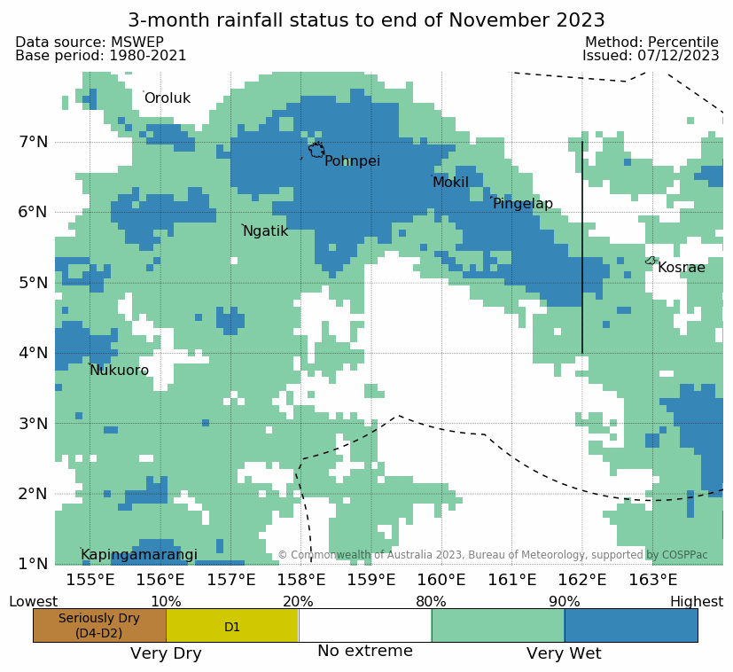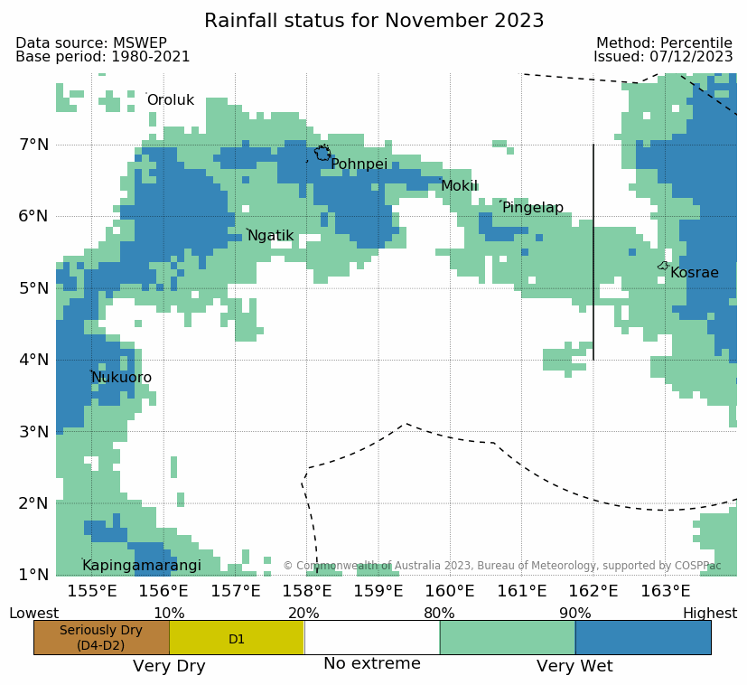

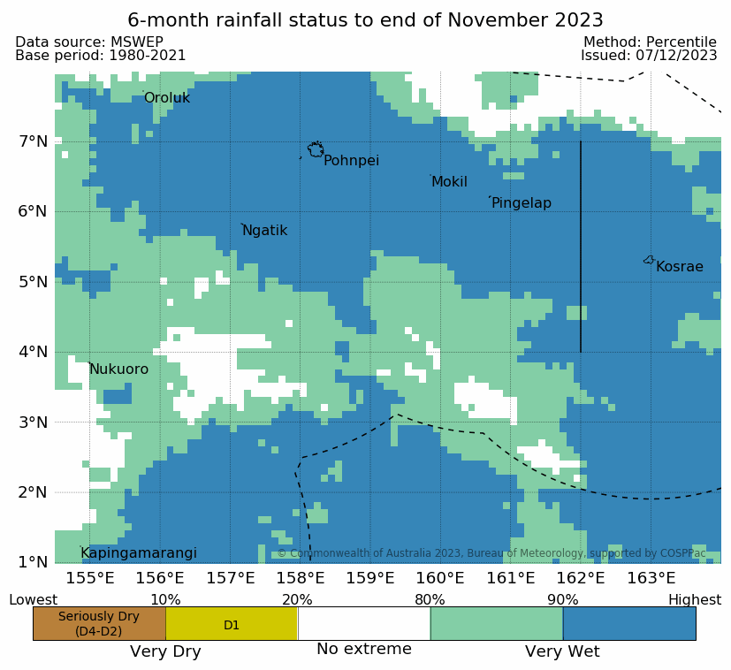

**Rainfall Outlooks for December 2023 to February 2024**

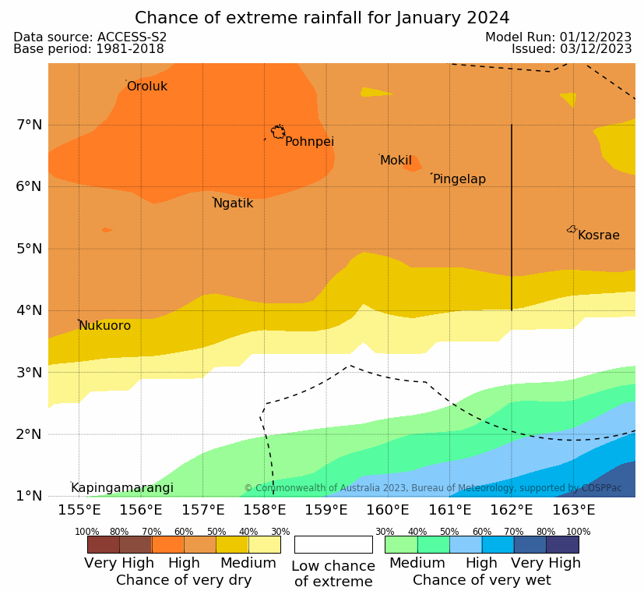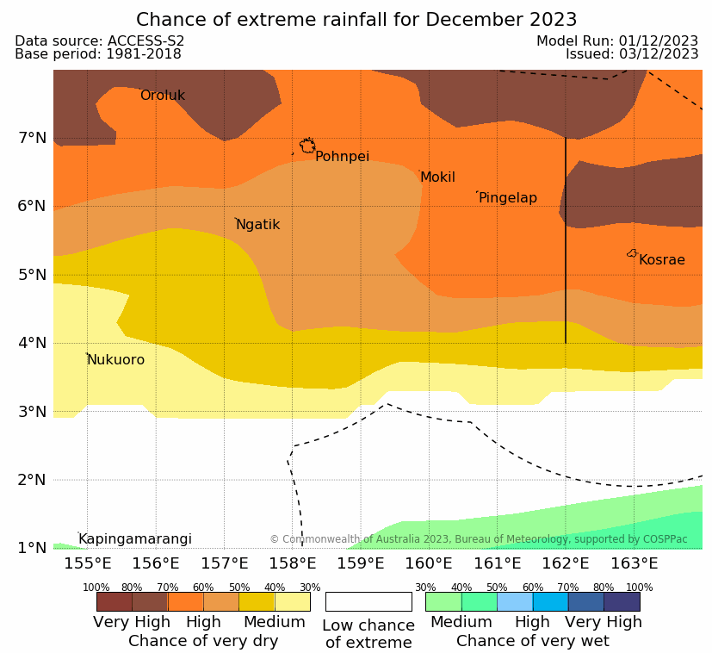

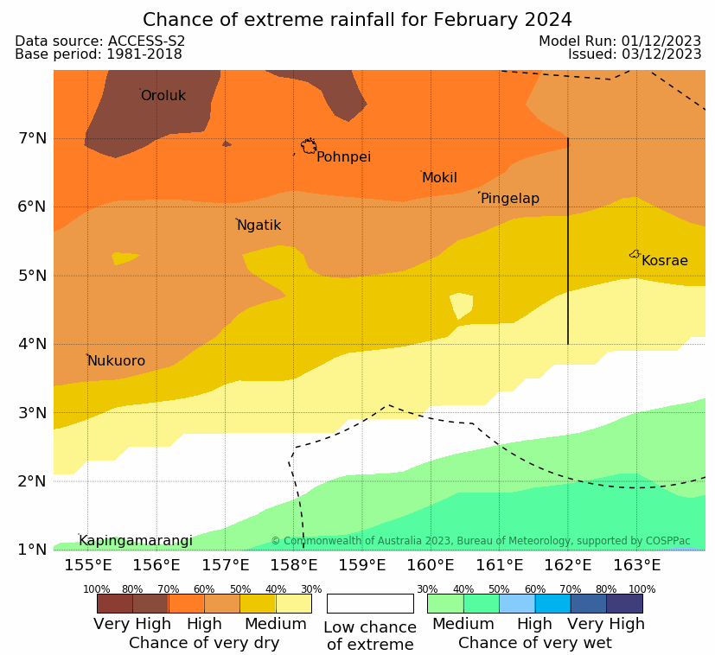

|  |
| --- |
| **About Rainfall Monitoring**  The 'rainfall status' maps are based on rainfall values from the MSWEP dataset which are then converted to the percentile index. The percentile index calculates the ranking of rainfall observed for a period against corresponding periods in the historical record for a particular timescale. MSWEP is a global precipitation product that combines rain gauges, satellite and ERA-5 reanalysis data and is provided at a 0.1° resolution. Seriously Dry is defined as meteorological drought assessed by rainfall data only. It corresponds to rainfall for that period being in the bottom 10% of the historical record. 'No extreme' indicates that rainfall is within the middle 60% of historical observations for the respective timescale. In other words, rainfall that is not 'extreme'. The 3-, 6- and 12-month timescales are more accurate representations of drought while the 1-month timescale can be used to provide an indication of recent 'dry (or wet) spell' conditions. |
| **About Rainfall Outlook**  The 'chance of extreme rainfall' maps are based on the likelihood of Very Wet or Very Dry conditions. This is equivalent to the chance that rainfall for that forecast period will be in the top or bottom 20% of historical observations for that selected period. The darker the shading, the more likely these extreme scenarios are. The white shading refers to a low chance of extreme which means the most likely scenario for that outlook period is for rainfall to be 'near average' or slightly below average or slightly above average (not Very Wet nor Very Dry). The outlooks have been produced using the [Australian Bureau of Meteorology ACCESS-S2 model](http://www.bom.gov.au/climate/ahead/about/model/access.shtml). |

Contact the following Weather Service Office Pohnpei for further information.

P.O Box 69, Pohnpei, FSM, 96941, Tel: (011) (691) 320-2248

https://www.weather.gov/gum/WSOPohnpei

Email: Eden Skilling [eden.skilling@noaa.gov](mailto:eden.skilling@noaa.gov)